China central bank to skip open market operations today: statement
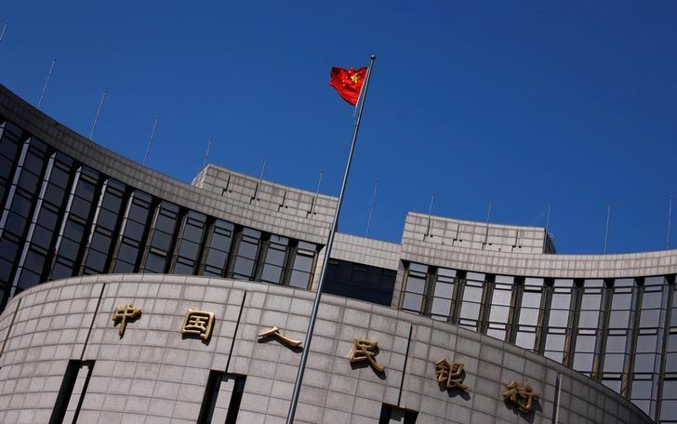
FILE PHOTO: A Chinese national flag flutters outside the headquarters of the People's Bank of China, the Chinese central bank, in Beijing, Mon Jun 26, 2017 | 9:24pm EDT China April 3, 2014. REUTERS/Petar Kujundzic/File Photo http://www.reuters.com/article/us-china-openmarket-repo-idUSKBN19I05K?il=0
China's central bank said it will skip open market operations for the third consecutive day on Tuesday as liquidity levels in the banking system were "relatively high".
"Fiscal expenditure were increasing towards the month-end to counter maturing reverse repos, liquidity in the banking system was staying at relatively high level," the People's Bank of China said in an online statement.
Maturing reverse repos will drain a net 10 billion yuan ($1.46 billion) from the market for the day.
http://www.reuters.com/article/us-china-openmarket-repo-idUSKBN19I05K?il=0

