Evolution of the renminbi
Published: April 3 2008 12:33 | Last updated: April 3 2008 12:33
http://www.ft.com/cms/s/0/8adee7ba-016e-11dd-a323-000077b07658,dwp_uuid=af522be6-4c8c-11da-89df-0000779e2340.html
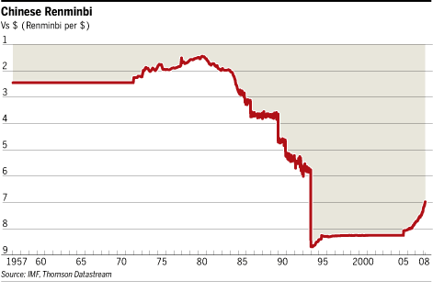
1949: creation of the renminbi
The renminbi means “people’s currency” in Chinese. It is first issued in 1949, shortly before the Communists take over the mainland, as part of a fight against the hyperinflation that has plagued China under nationalist Kuomintang party’s rule.
1950 - late 1970s: overvalued fixed rate
Used as a tool for financial planning under the command economy, the renminbi exchange rate is fixed at overvalued levels against western currencies for decades. Strict control of currency exchanges results in an active black market.
1978 - 1993: repeated devaluation
After China opens up its economy at the end of 1970s, the central bank starts to devalue the renminbi repeatedly to help exports and attract investment.
The official renminbi exchange rate is lowered to Rmb5.8 against the US dollar at the end of 1993, down 73 per cent from the Rmb1.58 level at the beginning of 1979.
The average nominal and real exchange rates of renminbi against major trading partners fall by 68 per cent and 76 per cent, respectively, during the period.
Currency exchanges are still severely controlled. For most of 1980s a dual-track system is in place, under which the renminbi is usable only domestically, and foreigners are forced to use foreign exchange certificates.
The system is abolished in early 1990s, after the establishment of foreign exchange swap centres makes the renminbi more convertible.
1994 - 1996: managed floating rate
The official renminbi exchange rate and the foreign exchange swap market rate are integrated on January 1, 1994, starting a market-based, managed floating rate system. Upon the move the official renminbi exchange rate is lowered by 30 per cent.
Under the new system the renminbi is allowed to fluctuate against the US dollar within a narrow daily band, which has been successively tightened over time and currently stands at 0.002 per cent, with the central parity being the previous day’s close. That means the renminbi can appreciate or depreciate against the US dollar, but only very gradually.
Between 1994 and 1996, the renminbi strengthens 5 per cent from Rmb8.7 against the dollar to below Rmb8.3, and continues to fluctuate around Rmb8.3 through the latter part of 1997.
The renminbi’s average nominal and real effective exchange rates against trading partners rise by 10.2 per cent and 38.7 per cent, respectively.
1997 - July 20, 2005: quasi-peg
As the 1997-1998 Asian financial crisis deepens, China’s central bank intervenes heavily to curb capital outflows and adopts a quasi-peg regime. The renminbi is virtually fixed against the US dollar, but not completely - it can still move within its daily range, but the central bank has not let it move beyond a cumulative deviation of 0.01 per cent from Rmb8.277 against the dollar.
The exchange rates of the renminbi against other currencies have experienced bigger fluctuations. Between 1998 and 2001, when most of the world’s currencies weaken against the US dollar, the renminbi’s average nominal and real effective exchange rates rise by 11.5 per cent and 9.8 per cent, respectively.
With a weaker dollar since 2002, China’s currency peg has come under increasing criticism. Trade partners, led by the US, EU and Japan, say China keeps the renminbi exchange rate at a significantly undervalued level to give its products an unfair price advantage in the global market.
July 21, 2005: revaluation and termination of peg to US dollar
China scraps the renminbi’s decade-long peg to the US dollar, adopting a managed float against a basket of currencies. The renminbi is revalued by 2.1 per cent, appreciating immediately to Rmb8.11 against the dollar from Rmb8.28. Starting on the day the currency is allowed to fluctuate, up or down, by 0.3 per cent against the dollar, while moving in a wider band of 1.5 per cent, up or down, on other currencies in daily trading.
People’s Bank of China, the central bank, says the exchange rate will in future be adjusted “according to market developments as well as the economic and financial situation.”
Source: UBS
Copyright The Financial Times Limited 2008

