Next financial crisis will hit with a ‘vengeance’ and Canada is especially vulnerable
The Telegraph, Financial Post 06.26.2017 By Ambrose Evans-Pritchard http://www.vancouversun.com/next+financial+crisis+will+with+vengeance+canada+especially+vulnerable/13549144/story.html
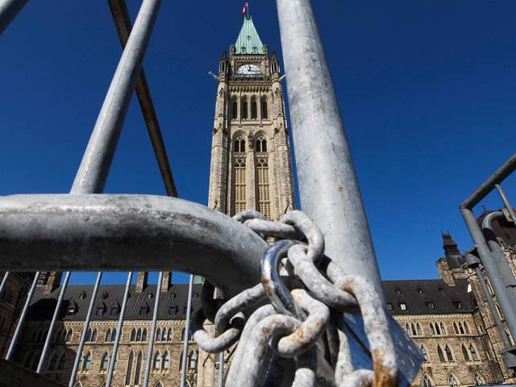
The world's top monetary watchdog says early warning indicators for financial crises are already flashing red in China and Canada. Postmedia News / Financial Post
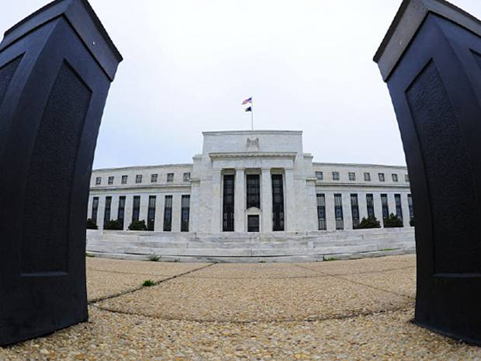
Fed rate rises will start to drain the global system of dollar liquidity, setting off a dollar squeeze and driving up borrowing costs across much of the world.Getty Images / Financial Post
The global economy is caught in a permanent trap of boom-bust financial cycles, a deformed structure becoming ever more corrosive and dangerous as debt ratios rise to nosebleed levels, the world’s top monetary watchdog has warned.
The Bank for International Settlements said the rot in the global monetary system has not been cut out since the Lehman crisis in 2008. The current, now ageing cycle could finish in much the same explosive way, contrary to the widespread belief that the financial crisis of 2008 was a once-in-a-century event caused by speculators.
“The end may come to resemble more closely a financial boom gone wrong, just as the latest recession showed, with a vengeance,” said Claudio Borio, the BIS’s chief economist.
The venerable Swiss-based BIS said the financial system was about to be tested as the U.S. Federal Reserve stepped up the pace of monetary tightening. A decade of ultra-loose money had kept the lid on debt service costs and masked risk.
“Policy normalization presents unprecedented challenges,” the BIS’s annual report said. It could “trigger or amplify a financial bust in the more vulnerable countries.”
Fed rate rises will start to drain the global system of dollar liquidity, setting off a dollar squeeze and driving up borrowing costs across much of the world, the report said “The overarching issue is the global economy’s sensitivity to higher interest rates,” it said.
Aggregate debt ratios are almost 40 percentage points of GDP higher than a decade ago. The rises have been eyewatering: China up 191, Canada up 70, France up 67, Japan up 52, and Korea up 49. The Anglo-Saxons have been more restrained, with the U.K. up 36, and the U.S. up 29, but they were already steeped in debt.
The risks of tightening does not mean that the Fed should hold back, the BIS said. Central banks were now damned if they do, and damned if they don’t. “A strategy of gradualism is no panacea, as it may encourage further risk-taking,” the report said. Ultimately you have to take your medicine rather than storing up ever more trouble for later. Critics say this is a recipe for revolution in the current febrile mood.
The “great unwinding” of central bank largesse comes as early warning indicators for financial crises are already flashing red in China and Canada, and are approaching storm levels across large swathes of emerging Asia.
Borio said the gloom was overdone early last year. Now exuberant investors may be making the opposite error, with the world 12 months further into a stretched financial cycle. “One may legitimately ask whether sentiment has swung too far,” Borio said.
Those hoping to time global asset markets by waiting for the usual signs that the cycle has peaked risk being caught off guard. The deflationary forces of technology and a globalised labour force mean that trouble can creep up on them before inflation emits the usual warning signals.
The centre of risk has rotated (mostly) from Western economies to East Asia and the emerging market nexus, though Europe’s banks remain a powderkeg. This spells trouble. Developing countries now account for the lion’s share of global growth.
The BIS said it was impossible to know when the next eruption of stress will occur, but its early warning indicator for banking crises needed watching. “Credit-to-GDP gaps have reached levels signalling elevated risks in a number of emerging market economies,” it said.
The banking system is as badly stretched in parts of Asia as it was in Europe and America in 2008, though this time Canada has also blown through the safety barrier, with a roaring property boom.
The BIS stress model measures how far credit growth has raced ahead of trend rates for each economy. Any reading above 10 percentage points of GDP is a red alert. It has reached 30.3 in Hong Kong, 24.6 in China, 14.1 in Canada 11.3 in Thailand, 9.7 in Malaysia, 9.3 in Indonesia, 9.0 in Mexico, and 7.2 in Turkey. All are vulnerable. So is Switzerland at 7.6. The gauge flags trouble three years in advance. The longer it goes on, the worse it is.
The debt service ratios for Hong Kong, China, and Canada suggest they would be in serious trouble if interest rates were to rise by 250 basis points. France and Australia are borderline.
While the BIS said such a rate surge was unlikely, some analysts warn that the People’s Bank of China may lose its room for manoeuvre and find itself having to tighten “pro-cyclically” into a credit crunch to stabilize the yuan.
What is clear is that any rise in U.S. borrowing costs is transmitted rapidly through the global system. China is not immune, and the levels of leverage are off the charts for a developing country. Total debt is 255 per cent of GDP.
What makes this global picture so combustible is the legacy of cheap dollars that washed across international finance when the Fed slashed rates to zero and launched quantitative easing.
Offshore dollar debt outside U.S. jurisdiction, with no direct lender-of-last-resort behind it, has risen by 50 per cent to US$10.5 trillion since 2008. The dollar itself acts as a kind of “fear gauge”. When it strengthens, banks in Europe and Asia shrink balance sheets through the mechanism of hedge contracts.
The BIS report said: “Global U.S. dollar funding markets are likely to be a key pressure point during any future market stress episode. There are significant roll-over risks, as sizeable parts of banks’ U.S. dollar funding rely on short-term instruments (repos, and currency swaps).”
Emerging markets have better buffers than they had in the dollar-driven Asia/Russia crisis in 1998. Foreign reserves are three times higher as a share of GDP. Most have abandoned fixed currencies. But the scale of borrowing has taken them into uncharted waters.
The BIS says an unsettling pattern has emerged over the past quarter century. Under the old “Phillips Curve” model, wage growth would pick up late in the cycle as the economy reached full employment. This would lead to an incipient wage-price spiral. Inflation would pick up. The Fed and other central banks would then hit the brakes. It would usually end in recession. It was Hobbesian but clear.
Globalization has suppressed the inflation warning signal. The entry of two billion people into the global economy from China and Eastern Europe has dampened wage growth. “A substantial and lasting flare-up of inflation does not seem likely,” the BIS said.
Excess stimulus by central banks goes into asset bubbles instead. It may look benign if inflation is low but the BIS argues that it is extremely damaging. The cycle ends with a financial crisis. This is what happened with the dotcom boom at the end of the 1990s, when the Shiller price-to-earnings ratio for Wall Street’s S&P 500 index reached the highest levels since data began in the late 19th century. It is happening again. The Shiller ratio is approaching 30, double the median level for the past 130 years.
While the BIS is careful not to criticize the Fed, the views clash. The Fed under current chairman Janet Yellen is wedded to the old Phillips Curve model. This might cause it to wait too long before raising rates, or raise them too slowly as it did from 2004 to 2006.
The implicit BIS critique is that the big central banks misread the globalization era. They have a bias towards easy money. They reacted asymmetrically, letting assets booms run, but stepping in with maximum stimulus in busts. Hence the market’s belief in the “Fed Put”, and the moral hazard that goes with it. The ratio of “zombie” companies keeps climbing, in a chronic failure to burn off the dead wood, the “creative destruction” described by the economist Joseph Schumpeter.
The Fed and others have in effect drawn forward prosperity from the future. It takes ever lower real interest rates with each cycle to hold the system together. At some point interest rates will hit the limit. The BIS says the only way for the world to dig itself out of this hole is to raise productivity from its current anaemic levels. Countries must reform and shift fiscal policy from consumption to investment.
As for globalization itself, the BIS report says it has lifted hundreds of millions out of poverty and has been a bonanza for mankind. Yet it has been managed carelessly. It has let the owners of capital pit Western workers against Eastern workers, driving down wages through labour arbitrage. The labour share of GDP has plummeted. Inequality has soared. Hot capital flows have overwhelmed vulnerable countries and stoked credit bubbles.
The imperative is to tame the system. The BIS says the most destructive course is to scapegoat free trade itself and heed the siren calls of protection. “Rolling back globalization would be as foolhardy as rolling back technological change,” Borio said.

