Oprah Winfrey Is On a Roll (Again)
August 15, 2017 1:00 AM by Jonathan Van Meter|photographed by Annie Leibovitz http://www.vogue.com/article/oprah-winfrey-vogue-september-issue-2017

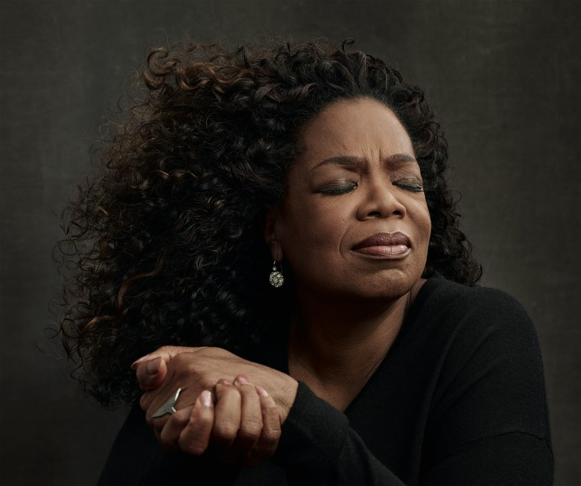
Like a Prayer
“I have no angst, no regret, no fear,” Oprah says.Photographed by Annie Leibovitz, Vogue, September 2017
It is the golden hour in the Promised Land, and we are walking down Hallelujah Lane, going to see the Apostles. Only at Oprah’s house can one come up with a sentence like that as a literal description. Translation: It is a beautiful early evening in May, and Oprah and I are walking along one of the cobblestone lanes she has built on her 65-acre California estate, a startlingly beautiful landscape she calls the Promised Land. We are heading toward her favorite spot, where, under the shade of a spectacular live oak, she often lies on a chaise and reads. The tree is just one in a grove of twelve (the Apostles), and it is hard to tell where one tree ends and the next begins, their endless branches twisting and curling in a gorgeous, spooky tangle.
It’s no accident that this place is reminiscent of a Southern plantation. Right around the time her movie Beloved, the film adaptation of Toni Morrison’s Pulitzer Prize–winning novel, tanked at the box office in the fall of 1998—and after “Deliverance moved in next door” to her farm in Indiana—Oprah decided she needed to make some big changes, and so she began looking to buy an actual Southern plantation. Her fitness guru Bob Greene was scouring for such a place when he stumbled on this property: 42 acres of paradise perfectly situated between the Santa Ynez Mountains and the Pacific Ocean. (Last year, when her neighbor died, Oprah outbid a developer for another 23 acres.) Oprah bought it in 2001 and began a five-year construction and landscaping project—managed by Greene—that included planting a forest of mature oaks and building a fountain the size of a lake that shoots water to the heavens.
“I was calling it Tara II,” says Oprah, “and one day Bob and I were walking around the property and he said, ‘Scarlett O’Hara wishes she had this. Scarlett was not living like this.’ So he goes, ‘You need a better name. The fact that you are an African-American woman from Mississippi and you get to have this . . . it’s deep.’ So I go, ‘Yeah! It’s like a dream.’ And he’s like, ‘Yeah! It’s a promise! It’s the Promised Land!’ So I feel that every day. I don’t know of a person who can honestly, deeply, profoundly speak to the word contentment. I’ve tried to talk to other people about this thing: I have no angst. No . . . nothing. No regret, no fear. I mean . . . just absolute joyful contentment.”
When I first arrived around lunchtime, a handsome fellow in a golf cart—Oprah’s head of security—appeared at the gate to take me to the house, and as we bumped along the cobblestones, her enormous neo-Georgian mansion came into view. We passed workers on other golf carts, men clipping hedges, an elaborate formal rose garden, a pond with ducks. He deposited me in the house in a room off the kitchen, where a small army of women in uniforms scurried in and out. Someone offered me a sandwich, which was served with a place setting of vintage silverware, a Venetian water glass, and a beautiful linen napkin with a hand-embroidered O.
I heard a rustling in the kitchen, and suddenly Oprah appeared from around a corner in a bathrobe and slippers. The photo shoot with Annie Leibovitz was running long, and she didn’t like that we had not yet said hello. “Annie was saying, ‘I hope I’m not keeping you from Jonathan,’ ” she says. “I go, ‘I’m not worried about Jonathan. Because I can only concentrate on being here with you right now. And then when I’m with Jonathan, I will be with Jonathan and I won’t be thinking about you!’ She let out a big laugh and, as she was walking away, said, “I have learned that being-fully-present thing. I am 1,000 percent fully present.”
When the shoot is finally over, I am taken to the teahouse, a romantic, open-air stone structure Oprah built for the sole purpose of reading The New York Times in the morning while drinking her tea. There are orchids everywhere, stacks of gardening books, and voluminous green wicker sofas and chairs. The first time I interviewed her for this magazine was in 1998, when I spent three summer days hiking in Telluride with Oprah, her best friend and colleague Gayle King, and Bob Greene as Oprah was getting ready for the press rollout for Beloved and her Vogue cover shoot, for which she was training and dieting to lose 20 pounds. The hikes were brutal; the meals afterward, cooked by her then-chef, Art Smith, spartan. I was not there to lose weight but came home several pounds lighter. During one of those hikes, I asked if she had ever imagined she’d be on the cover of Vogue. “Dreamed to be in Vogue? I’m a black woman from Mississippi . . . I would never have even thought of it as a possibility . . . I’ve been fighting weight all my life, definitely never even thought of myself as an attractive girl.” She laughed. “So why would I be dreaming about Vogue? Vogue is the big house! Didn’t think I’d be sittin’ at that table!”
Oprah was not yet the wealthiest African-American person in the world, but she was rich as Croesus, arguably the most famous person alive, and at the height of her powers: Everything she touched turned to gold; every book she promoted became a bestseller. “I shall never forget Saturday morning, October 17,” says Oprah—the day after Beloved opened. “I got a call from someone at the studio, and they said, ‘It’s over. You got beat by Chucky.’ And I said, ‘Who’s Chucky? What do you mean it’s over? It’s just Saturday morning!’ I knew nothing about box-office projections or weekend openings. It was ten o’clock in the morning, and I said to Art, “I would like macaroni and cheese for breakfast.” She starts to laugh. “And soooo began my long plunge into food and depression and suppressing all my feelings.”
What had been “the happiest time I’ve ever spent on the planet” had turned into her most miserable failure, and she sank like a stone. “I actually started to think, Maybe I really am depressed. Because it’s more than ‘I feel bad about this.’ I felt like I was behind a veil. I felt like what many people had described over the years on my show, and I could never imagine it. What’s depression? Why don’t you just pick yourself up?” Her depression lasted all of six weeks. She stopped running around to movie theaters where Beloved was showing to buy blocks of tickets to try to get the box office up (true story) and pulled herself together. “That’s when the gratitude practice became really strong for me,” she says, “because it’s hard to remain sad if you’re focused on what you have instead of what you don’t have.”
Her very public failure also taught her to detach. “It taught me to never again—never again, ever—put all of your hopes, expectations, eggs in the basket of box office. Do the work as an offering, and then whatever happens, happens.” Oprah is convinced the film was ahead of its time; that it would be received very differently today. She points to the television show Underground. “When someone first mentioned that to me, I go, ‘Nobody’s going to watch a TV show about slavery.’ ” She rolls her eyes. “12 Years a Slave? When that became a hit, I went, Wow. OK. The culture has shifted.”
People can argue over whether Beloved was too difficult for audiences at the time, but it made one thing clear: Oprah—who was also dazzling in 1985’s adaptation of Alice Walker’s novel The Color Purple—is a naturally gifted actress. Which is why it came as a bit of surprise that she did not act in another film until 2013’s Lee Daniels’ The Butler. At the time, she was in the midst of the difficult launch of OWN. “I was trying to start the network, finish a scene, go off to do an interview, come back, do another scene for two days, and then leave again,” she says. “So I realized that no other actor is doing that. No other actor is trying to run a network, be on the network, be the network. And! Also! With Lee Daniels saying, ‘Now, I want you drunker! I want her to be drunker!’ ”
Since The Butler, Oprah’s been on something of a roll: A year later she produced and appeared in Ava DuVernay’s Selma, and this past spring she starred in HBO’s The Immortal Life of Henrietta Lacks, directed by George C. Wolfe. “Oh, man,” she says. “I was so afraid of that thing. Now I’m glad I did it. I was intimidated by the work, but in the end, what’s the worst that can happen? You get bad reviews—but in the age of Trump, it will be over in a day.”
Perhaps the main reason Oprah has returned to film acting is not just the recent uptick in the availability of actual roles for black women over 60, but also that she is being asked to return: by men and women who admire not just her work in Beloved and The Color Purple but also the person, the self-made legend. She has had a profound influence on our culture, not to mention our politics, given that many feel Barack Obama might not have made it across the finish line without her tireless support for him during his first presidential campaign, in 2007.
When I ask her if she wants to do more acting, she pauses for a very long time. “Well,” she finally says, “I don’t think about it.” Another long pause. “If something were to come along and move me to the point that I would be willing to get up and leave here for a period of time. . . .” Which is exactly what happened last year, when DuVernay offered her a part in A Wrinkle in Time, a Disney adaptation of the wildly popular Madeleine L’Engle young-adult fantasy novel published in 1962. DuVernay is the first woman of color to direct a live-action film with a budget of more than $100 million, which may help explain why this is the first film Oprah has appeared in that has nothing to do with the African-American struggle for equality. The story includes the three Mrs. W’s, supernatural beings who in the book are all, says Oprah, “kind of like Mrs. Doubtfire.” (DuVernay, in a play for diversity, cast Mindy Kaling as Mrs. Who, Reese Witherspoon as Mrs. Whatsit, and Oprah as Mrs. Which.)
The film, out next March, was shot in part in New Zealand, which Oprah had first visited in 2015. She loved it so much that she has been itching to go back. “I am telling you: If you want to expaaand yourself as an individual on the planet Earth, New Zealand’s the place to go. The people are 100 percent present. They are not walking across the street on their cellphones. Every single corner you turn, there is some breathtaking something or other going on: Lakes! Glaciers! Eagles! It’s crazy.” When I tell her she is the third person in a week to bring up New Zealand, she says, “Do you believe in signs?” and when I hesitate for just a second too long, she says, “Have I taught you nothing? All these years? Of course it’s a sign!”
Oprah was 44 when she made Beloved. Now she is 63. What I want to know is: What does 63 know that 44 didn’t? She pauses for a long time. “In your 40s, you’re coming into it, you’re intellectualizing things, and you kind of know it and you feel it,” she says. “But there is a deepening and a broadening and quickening of the knowing that happens in your 50s. Maya Angelou used to say to me, ‘The 50s are everything you’ve been meaning to be.’ She looks at me over the top of the nerd-chic glasses she favors these days. “You’d been meaning to be that person.” She laughs. “By the time you hit 60, there are just no . . . damn . . . apologies. And certainly not at 63. And the weight thing that was always such a physical, spiritual, emotional burden for me—no apologies for that either.”
Interviewing people who interview people for a living presents a special challenge: They know what you’re up to. You feel as if you’re being quietly judged. Not with Oprah. Once she’s committed, once she’s present, there is a kind of flow and trust that develops on the spot. Oprah, by her count, has interviewed more than 37,000 people during her 25 years of doing the The Oprah Winfrey Show in Chicago. When I ask her if there is one big takeaway, she says, “Absolutely. There’s not a human being alive who doesn’t want—in any conversation, encounter, experience with another human being—to feel like they matter. And you can resolve any issue if you could just get to what it is that they want—they want to be heard. And they want to know that what they said to you meant something. Most people go their entire lives and nobody ever really wants the answer to ‘How are you? Tell me about yourself.’ And what was so beautifully . . . what is the word? . . comforting about what happened every day on the Oprah show is that people would dress up like they were going to church. Sometimes I would notice somebody and I would say, ‘Oh, wow, that’s a really pretty green dress.’ And she would go: ‘I wore it for you! I knew you would notice me!’ People just want to be seen; they want to be validated.”
It’s been more than six years since the last Oprah Winfrey Show aired. Though Oprah says she misses “my audience connection and my exchange with them,” she does not miss Chicago and the daily grind of a daytime talk show. Oprah began to read the tea leaves around 2006. “I started thinking about the times: where we were, would I be able to take it digital. People were moving into ‘I want to be able to watch it when I want to watch it,’ and the four o’clock hour was no longer must-see television. I could feel that happening with the audience. Their behaviors were shifting, and the media world was changing. I had written something in my journals years before: ‘I never want to stay too long in the ring so I end up punch-drunk.’ I didn’t want people saying, ‘She shoulda quit that show three years ago!’ ”
And then one night she got a sign. She was in a hotel in London, and there was a copy of Vanity Fair in her room. “I started reading this incredible article about Michael Jackson, and one of Jackson’s friends was quoted as saying, ‘His number-one problem is that he never realized that Thriller was a phenomenon. And he spent the rest of his life trying to chase it.’ And so, when Bad only sold—only sold—20 million albums early on, he was disappointed because it wasn’t Thriller. He thought he was going to top Thriller. I went, Whoa. Pay attention to that. I didn’t want to be the person chasing a phenomenon. And that is what the Oprah show was. All the right elements came together at the right time. That won’t happen again. People would ask me, ‘Who will be the next Oprah?’ And the answer is: ‘There won’t be.’ ”
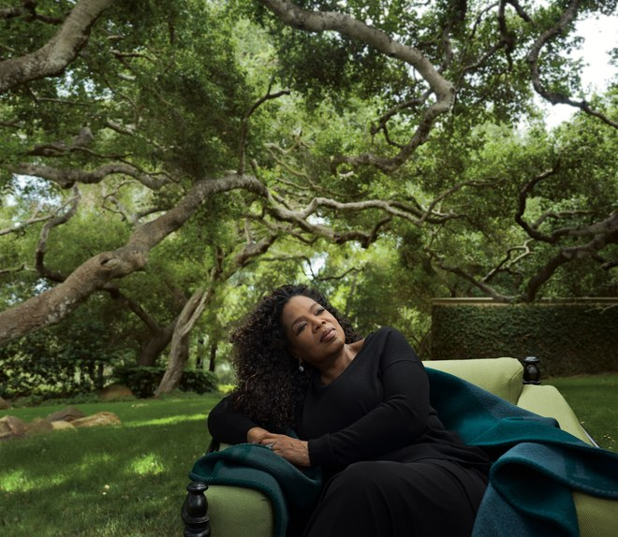
Going Green
Oprah—at home amid a grove of twelve live oaks she’s dubbed the Apostles—calls her plantation-style estate and grounds the
Promised Land. The Row sweater and skirt. Photographed by Annie Leibovitz, Vogue, September 2017
Oprah likes to talk about “intention.” What do you hope to achieve? Why are we here? At one point, I ask her what her intention was in starting OWN, the television network she launched in 2011. She starts to laugh. “Ohhhhhh, I was so misled in my thinking. I thought I was going to create a network that was Super Soul Sunday all day long. I thought people. . . .” She’s laughing harder. “I thought I was going to bring this spiritual consciousness–awakening channel! And I soon learned: Ain’t nobody care about that. And the people told me: We’ll listen to you on Sunday, but that’s it. I was going to be the Anthony Bourdain of spirituality. I was going to go from country to country interviewing people in backwoods, in igloos, on mountaintops all over the world, bringing you a look at spiritual consciousness.” She levels me with a look. “And honeeeey chiiiild, didn’t I learn!” Now she is cracking up. “Oh, my God. America is not ready to be awakened in that way! So what I learned is, you got to give them—what did I call ’em?—snackables! You need snackable spirituality—snackable, digestible moments in an entertaining format, so people can receive it.”
After a rocky start, followed by an exclusive partnership with Tyler Perry and then a realization that reality TV and soap operas might be necessary evils when you are programming for 24/7/365, OWN has finally found its métier. “The real truth,” says Oprah, “is that we’re in the best place ever. We were able to use Tyler’s audience to build a great foundation for scripted television, and now I am moving into an elevated premium scripted storytelling in a way that I have been dreaming of for a long time.” (In July, Perry announced that he’d be leaving the network in 2019, when his contract expires.) To that end, she has partnered with people like Mara Brock Akil, the screenwriter/producer best known for creating Girlfriends and Being Mary Jane. “She and her husband, Salim, are creating a drama on black love and their life as a sophisticated black couple in Hollywood.” Oprah has just announced a first-look deal for television with film producer Will Packer and director DuVernay; she is renewing Queen Sugar and Greenleaf. “I just had a big meeting with Michael B. Jordan and Tarell Alvin McCraney, who co-wrote Moonlight.
“I’m excited because I’m building my storytelling tribe,” says Oprah. “I’m gathering around myself a group of great producers, great writers. That’s what I’m thrilled about. Because I now get to do and say through drama all the things I was trying to say those years on the Oprah show. I get to take all of that energetic . . . dysfunction from thousands and thousands of conversations on the Oprah show and turn it into real drama.”
This September, Oprah will return to broadcast television for the first time since her talk show ended (there was a one-off interview with First Lady Michelle Obama last December on CBS), joining 60 Minutes as a special contributor. But the story of how Oprah decided to return requires that we first go back to the election of Donald Trump. Two weeks after he won the presidency, O magazine decided to gather a group of Trump and Clinton supporters—all women—for a roundtable discussion. Feelings were still so raw that some of the women didn’t even want to sit at the same table. “One said, ‘I’ve never been this close to a Trump supporter,’ ” says Oprah. “I go: ‘Not that you know of, maybe.’ ” About an hour in, Oprah could see their guards coming down. “By pressing the conversation in such a way that people could hear each other’s stories without them being politicized, I was able to get those women from different backgrounds to begin to actually hear and feel for each other. By the end of that two and a half hours, I could have gotten them to sing ‘Kumbaya’ for real if I wanted to.” She cracks up. “I really could’ve! OK—everybody hold hands!”
Ironically enough, it was the moment when she realized that no one had filmed the discussion that a light switched on: Maybe, just maybe, this is exactly what America needs right now. Jeffrey Fager, the executive producer of 60 Minutes, had approached her several years earlier about collaborating, “but I was so engaged in OWN it wasn’t even, like, a thought,” she says. “And then [CBS Corporation chairman and CEO] Leslie Moonves brought it up, so there you go. It’s me being out in the center of the country doing that thing where you’re putting two sides together, and I am really looking forward to it.”
Fager says while the temptation to have Oprah do the sort of big interviews for which she’s known is enormous, “for us it’s about resisting that; what we’re setting out to do is conquer the divide in America, try to understand it better, try to shed some light on where these differences lie. I think a lot of people now realize that this was one of the great missed stories of our generation—that there is so much bitterness in America today—and we really see it as something that Oprah can help us better understand, and by doing that hopefully narrow that divide and start us talking again. Oprah has so much to offer, and I think that probably she’s been a little frustrated that she hasn’t had that grand place to offer it, and I think we bring that to her.”
The sun is beginning to set over the Pacific, and our interview is winding down. I ask Oprah, What has not getting married taught you about women in our society? “Live life on your own terms,” she shoots right back. Then she reiterates something she said to me nineteen years ago: that the subject of marriage between her and Stedman Graham never came up. “Nobody believes it, but it’s true. The only time I brought it up was when I said to Stedman, ‘What would have happened if we had actually gotten married?’ And the answer is: ‘We wouldn’t be together.’ We would not have stayed together, because marriage requires a different way of being in this world. His interpretation of what it means to be a husband and what it would mean for me to be a wife would have been pretty traditional, and I would not have been able to fit into that.”
We head back toward the house and on our way in pass a Henry Moore sculpture of a woman in recline. “I call her Paulina because she reminds me of my housekeeper in Chicago,” says Oprah. She wants to show me “not the quote-unquote best painting in the house, but my favorite painting in the house.” It has pride of place in her vast living room: a narrative painting—Oprah describes it as a pre–Civil War scene of a mother and daughter about to be separated at a slave auction—called To the Highest Bidder, by the Brooklyn artist Harry Roseland, who died in 1950. She takes me into her study through a hallway lined with drawings by Nelson Mandela. “He gave them personally to me,” she says. In the study, she heads over to a bookcase lined with books that all have identical jackets. “Here’s the prize of my life: all my first-edition Pulitzers from the very beginning.” She pulls one off the shelf and opens the cover: The Grapes of Wrath. “Come ooooon,” she coos in amazement, as if pulling a tablet from the Ark of the Covenant. And then one last thing: an ancient-looking piece of parchment, beautifully framed, hanging near the door. “When I was shooting Beloved, I actually had this in the trailer with me. They are the names of slaves—their ages, their prices.”
Pausing on my way out to use one of her many bathrooms before the drive back to Los Angeles, I say to Oprah, “Remember at your house in Telluride when you showed me your tub that was molded and shaped to your body?” “Yup,” she says. “I still have a nice bathtub. I major in bathtubs. I spend my time looking for the best possible bathtub a woman can buy. And actually, Stedman’s never been in this one. When I was in Chicago, he would ask for permission: ‘Can I get in your tub?’ And I would say, ‘Mmmmmm. . . . OK.’ ”
Where does this tub fixation come from?
“You know where it came from? I will tell you. Honestly.” Her voice drops down into her lower register, the one she employed on her show to indicate that what she was about to say was profound or difficult or particularly revealing. “It came from the fact that I was raised with my father in, like, an 1,100-square-foot house where we all shared the same tub. And when I would go back home, after having been in hotels and seeing that there are nicer tubs in the world, and there’s that little tub with a ring around it, where Comet could no longer clean the ring around the tub—and it was my job to clean it—because it has been permatized, I vowed if I ever got my own place, I was going to get myself a good tub!” She laughs. “That’s why I had eleven dogs at one point: because my father wouldn’t let me have the one dog that I carried from Milwaukee when I was this despondent teenager hiding a pregnancy. My father says, ‘This dog can’t come in the house.’ I was really distraught—and the dog had to live outside and developed mange and all that stuff, so I also vowed, If . . . IIIIIIII . . . evvvvvvvver git some money, I’m gonna have as many dogs as I want. One of the best moments was my father coming into the house in Indiana and the dogs are all over the place, and he says, ‘There’s nowhere to sit in this house! All these dogs!’ And I go, ‘Now, this is their home—you have to ask them if you can sit down.’ ” She laughs. “That’s how I’ve overcompensated: with dogs and tubs.”
In this story:
Fashion Editor: Phyllis Posnick.
Hair: Nicole Mangrum; Makeup: Derrick Rutledge; Tailor: Wendi Williams-Stern.
Produced by Suzanna Rees. Set Design: Mary Howard.

